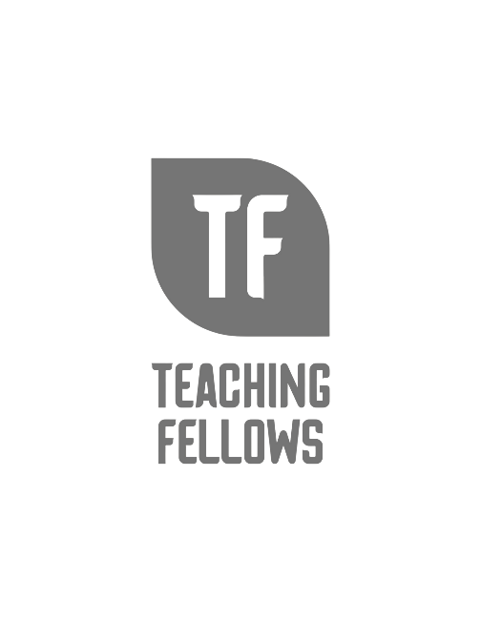
Teaching Fellows Junior Conference
Challenges and Opportunities: Why Poverty Matters and How YOU Can Matter More!
Dr. Tammy Pawlowski

Session Descriptor: While life in poverty sometimes provides a shaky foundation for life and school success, the latest research from neuroscience indicates that teachers can matter more. Take away resources that will help you reframe the challenges faced by teachers in high-poverty schools as opportunities for changing the futures for under-resourced students. Learn how YOU can have the most powerful impact on the students you teach.

Presenter Bio: Tammy Pawloski is Professor of Education and Director of the Center of Excellence to Prepare Teachers of Children of Poverty at Francis Marion University. She has led more than 2000 professional learning events for teachers, school leaders, and stakeholders. Tammy understands the challenges and opportunities of teaching and has devoted the last twenty years to the study of under-resourced learners—why they struggle, and which strategies have the greatest impact.

