Component 2: Differentiation in Instruction
Graphic Organizers- Architecture of Accomplished Teaching and Rubric
Plan: Component 2 Connecting Your Practice to the Five Core Propositions and the Architecture of Accomplished Teaching

Anticipated next instructional steps:

What evidence will you look for to determine next steps?

4th Step How/what will I use to assess student learning? How is it linked to my goals? | 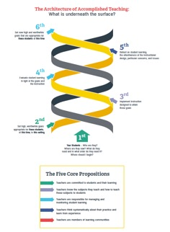 | 5th Step Reflection: What was effective and what needs improving? How do I know?
2nd Step What are my high, worthwhile Goals that are linked to my student needs? |  | 3rd Step What/how will my Instruction move my students towards my goals?
1st Step What do I know about my students?

© NBRC Stanford University 2019
Learn: Unpacking the Component 2 Rubric

- Print out your Level 2 and 3 Rubric for your Component 2. Lay them side-by-side so you can move across each bullet and compare.
- Start at the first bullet in Level 2 and underline the words that are different from the first bullet in Level 3. Highlight the words that are added in Level 3.
- Repeat for each bullet.
- Write a list of the key features that determine a Level 3 from a Level 2. Most candidates who don't certify initially score a 2 and miss by a few points for the cut score. It is critical that you understand the difference between a 3 and a 2.
- Write up a list of what is needed to score a 3. If you have time, look at Level 4 and add anything additional. Incorporate these into your Standard Organizer. Look for those topics in your component questions.

Example
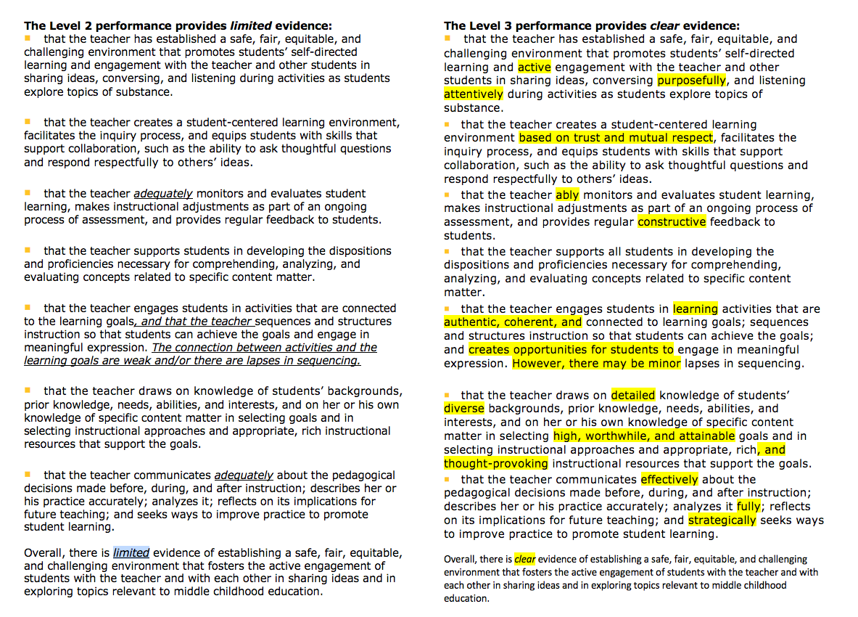

© National Board Resource Center at Stanford University

Learn and Revise: Connecting the Dots: Standards, Prompts and Rubrics

Plan and Learn |  |  | Revise & Finalize
Standards covered in this component | Component Prompt(s) | Rubric | Is this in your written commentary? Where?

Review and Finalize: Evaluating the Quality of Your Evidence

If your score on a portfolio component is between 3.75 and 4.25 inclusive, your performance has characteristics of the Level 4 performance. You have engaged in teaching and learning activities that exceeded the Standards for the component, and you submitted clear, consistent, and convincing evidence overall of having done so.

In addition to reviewing your notes in the Learn and Revise: Connecting the Dots: Standards, Prompts and Rubrics graphic organizer, you may want to assess the strength of your evidence using the feedback statements for Level 4 performance level for Component 2.

You provided clear, consistent, and convincing evidence to demonstrate that you: | Notes
Have a thorough knowledge of students as individual learners and set high, worthwhile, and attainable goals for student growth
Use varied, rich, and appropriate assignments and instructional resources
Are able to accurately and thoughtfully describe and analyze student work in ways that recognize students’ progress and offer means for students to build on their accomplishment
Engage in detailed and effective communication with students that directs their attention to the salient features of their work and encourages them to reflect upon how their work can be improved
Are able to describe your practice fully and accurately and reflect insightfully on its effectiveness in meeting the challenges of teaching

*Feedback statements can be found in The Scoring Guide

Updated: 10/18/21

